**Chapter 13: Homo sapiens… evolution of modern behav**

Adam Purvis

**Morphological Features of Modern Homo sapiens**

- Derived morphological traits 🡪 small face and teeth, pointed chin, high rounded cranium, less robust postcranium

- latest modern human fossils found in Europe, dated to 30kya

- Relatively long limbs, short trunks

- Cranial capacity of at least 1350 cc

**Archaelogical Evidence for Modern Human Behavior**

- Modern humans in Europe were able to accumulate complex adaptive and symbolic behavior in the same way as people living today

- Oldest homo sapien fossils found in Africa 200-100kya

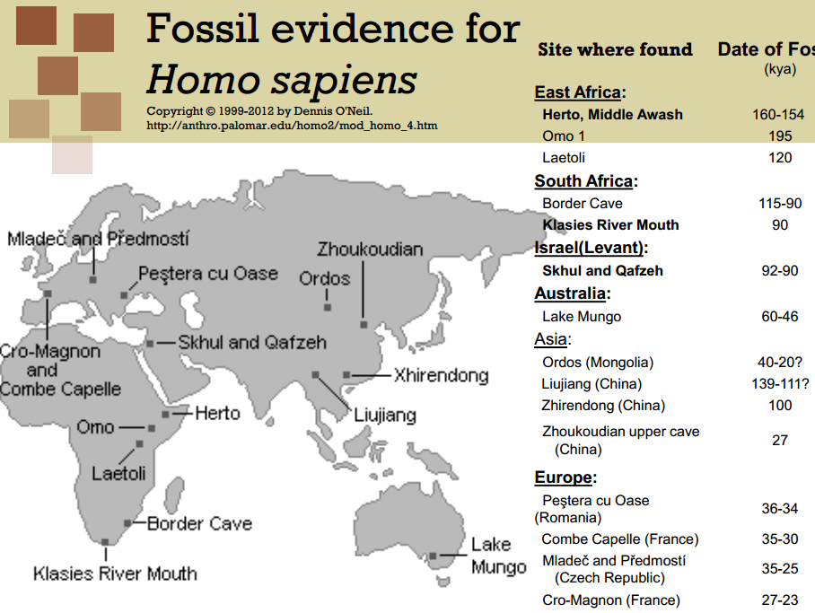

- Shows modern anatomy at 200-150kya

- Supports African origin, migration to asia, then Europe

- not conclusive because fossil record in spotty, some fossils ambiguous, dating is not always correct

- No information on population size

**Upper Paleothilic Technology and Culture**

- **Mode IV** technology: blades

- long, thin and flat with a sharp edge

- more cutting edge than flakes do; made more efficient use of raw materials than older tool technologies

- a large number of distinctive, standardized tool kits

- raw materials could be transported long distances (100s of kilometres)

- upper paleothilic industries varied in time and space

- exploited a wider range of prey species than Neanderthals, but subsistence economies of the two populations were similar

- big - game hunters; large animals played an important role in the diets of upper paleothilic people

- diverse vegetation too; horse, mammoth, bison, rhino, cave bears, wolves, some plant foods

- developed more complex forms of shelter and clothing than Neanderthals

- Upper paleothilic people may have begun the process of domesticating dogs

- Upper paleothilic people were better able to cope with their environment than the Neanderthals were

- Lived at higher population densities than Neanderthals; lived longer than Neanderthals; less likely to suffer serious injury than neanderthals

- Ritual burials during the upper paleothilic period

- Upper paleothilic people were skilled artisans, could sculpt statues of animals and humans, sophisticated cave paintings.

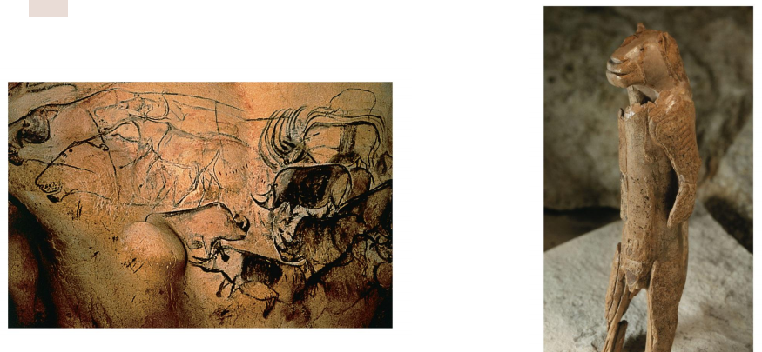

**Archaelogical evidence for modern human behavior… cont**

- Australia - occupied by modern humans 30kya

- How did they get to Australia? Must have made boats to cross 100km gap of ocean

- Arctic circle - occupied by modern humans approx. 30kya

- used sophisticated tools

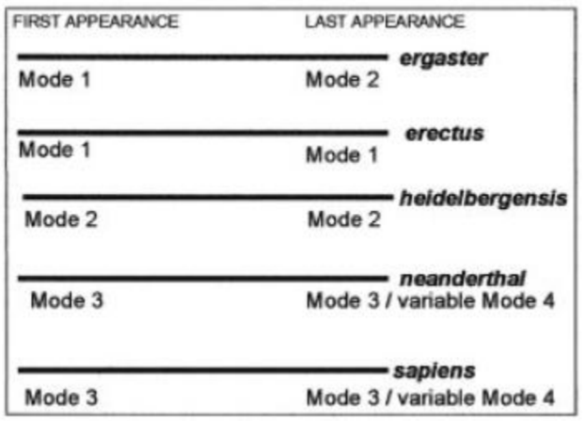

**Modern Human Behaviour, Revolution or Evolution**

- At 60kya, suddenly complex artifacts

- Between 200 and 60kya, were humans anatomically modern, but there was a human revolution at 60kya?

- Did complex behaviors appear gradually in Africa since 250kya?

**The African Archaelogical record**

- Mode 3 in Africa known as middle stone age (MSA); 250kya to 40kya

- Later stone age industries (LSA) distinguished by very small carefully shaped flakes called microliths; approx. 40kya 🡪 **Mode V** technology

**LSA vs MSA**

- LSA hunted larger and more dangerous game… MSA hunted large game but LSA hunted large game and concentrated on buffalo and bushpig, more dangerous species

- LSA engaged in more sophisticated planning

- LSA peoples engaged in more intensive foraging

**MSA**

- used blades, bone tools, composite tools halfted onto spears, heat-treated stone, long-distance transport, decorative carving

- engraved ostrich egg shells, engraved red ocher fragments

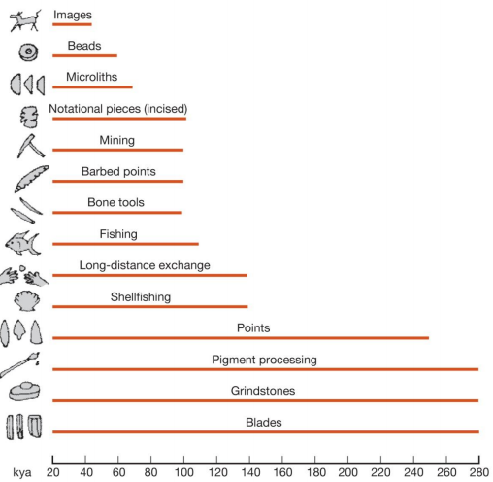

- regional variation in MSA industries across Africa

- Evidence for shelters and hearths… three arcs of stone blocks that served as wind blockers in mumbwa caves in Zambia

**Evidence from tools and artifacts**

- Initially, seemed that apparently more sophisticated tools appeared in Europe before Africa

- however, seems to be the result of more archaeological sites in Europe than Africa

- with more discoveries in Africa, we see a gradual change towards modern culture

- **\*\* we therefore reject human revolution hypothesis\*\***

**Genetic Features of Modern Homo sapiens**

- Human accelerated regions (HARs) which are conserved in other vertebrates show a recent, rapid amount of change in only the human lineage

- Many HARs (202) evolving rapidly in humans

- Noncoding but regulatory regions

- HAR1 regulates brain protein reelin that helps produce layered structure of the human brain

- regulatory gene differences between humans and chimps account for morphological differences

**The Origin and Spread of Modern Humans: Genetics**

1. modern humands evolved in Africa between 100-200kya

2. modern humans outside of Africa are all descended from a small population that left east Africa about 60kya

3. this population spread rapidly along the southern coast of asia and later moved north and west into Eurasia

4. there was a small amount of interbreeding between the expanding modern human population and the humans already living in Eurasia, the Neanderthals and the denisovans

- this information was all determined from genetic information and analysis

- Some of the information on genetic variation comes from genes carried on the Y chromosome or mitochondria

- Mitochondrial genes are different in that they’re not carried on chromosomes, they’re carried on mitochondria

- mitochondria carry small amounts of mitochondrial dna

- both males and females get mitochondria from their mother’s egg cell… mitochondria present in sperm aren’t transferred to ova, so there is no recombination in mtDNA

-**A child has exactly the same mitochondrial genes as its mother, unless there’s a mutation**

**Genetic Diversity in Humans**

- As a species we have a low genetic diversity compared to our nearest living relatives (i.e. chimps)

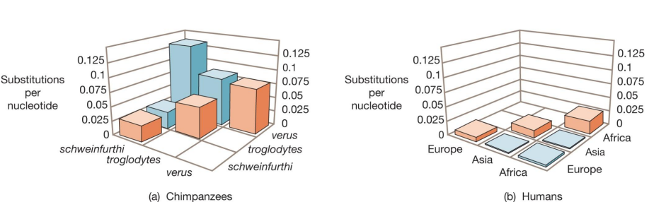

- This low genetic diversity indicates recent evolution perhaps a **bottleneck followed by very rapid population expansion**

- We’ve all descended from a small population of approx. 10,000

- Population genetic theory says that m = 2Nu, where N is the number of females and u is the rate at which mutations occur

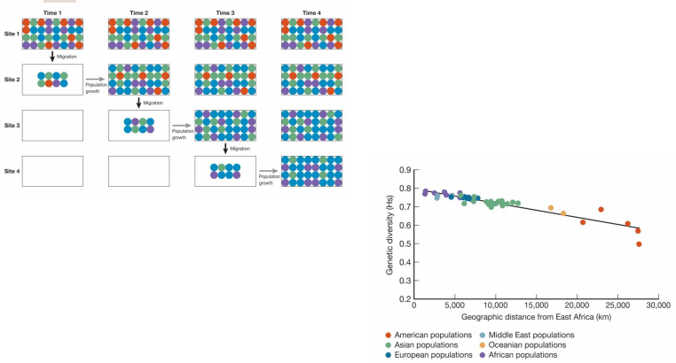- Geographic patterns of genetic variation are consistent with the expansion of human populations out of Africa

**Mitochondrial Eve**

- nonrecombining y chromosome (NRY)

- Different genes have different histories

- mutations accumulate over time, leads to gene trees

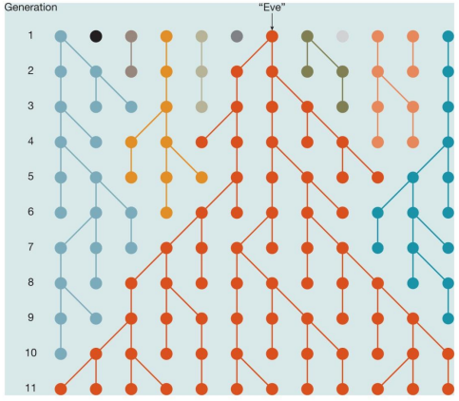- all copies of any extant DNA sequence that is transmitted without recombination can be traced back to a single copy in an individual who lived long ago

- The accumulation of mutations allows us to derive the phylogenic history of nonrecombining sections of DNA

- Gene trees support an African origin for modern humans… mutations must occur frequently enough for reconstructions of gene trees to be feasible

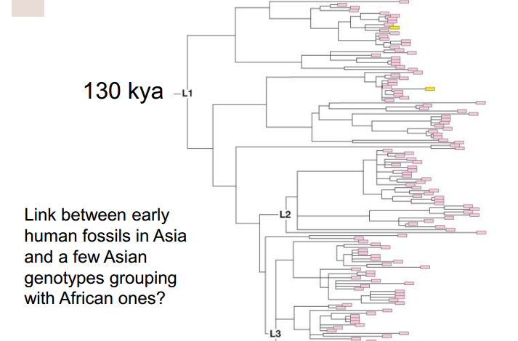- Genetic data hint that people spread first along the southern coast of asia and only later moved north into Eurasia

**The Molecular Clock**

- The rate of neutral evolution is predicted to be equal to the rate of neutral mutation in a gene sequence

- subject to lots of error - neutral mutation rates differ among genes; mutation times are random, not regular; rates of evolution can differ among the branches on a phylogenetic tree.

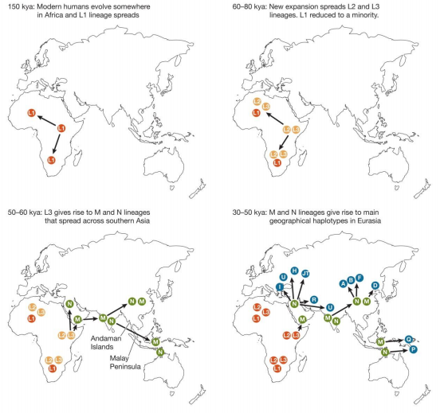

**How important was climate in migration?**

- Modelling population growth on climate (temperature and precipitation)

- Stimulating pedigrees of genes in correspondence with modern observations about genetic differences

- What they get are estimated parameters, which they can compare with known data

**Neanderthal DNA**

- Denisova 🡪 a cave in Siberia where a fingerbone was found

- The human and Neanderthal genomes are very similar, indicating that the last common ancestor of the Neanderthals and modern humans lived around 800kya

- Neanderthal had a LCA of 140kya

- Neanderthal and denisova genomes are more similar to each other than to modern humans but also indicate that these two hominins had different evolutionary histories

- the proposed hypothesis is that this is because of interbreeding; there was a modest amount of interbreeding between Neanderthals and the ancestors of modern humans in Eurasia, but not Africa.

**Neanderthal tool cultures**

- Mode IV 🡪 h. sapiens, first upper paleolithic European tool culture is Aurignacian (41kya)

- Mode III homo neanderthalensis in Europe is Mousterian

- Evidence that Neanderthals learned new techniques from humans… the transitional tools of the **Chatelperronian industry** to go along with the Mousterian and Aurigician industries